**Bubbles under the Sun**

——Prediction of Next Stock Disaster

Zhang Jingwei, Zhang Zichun,Zhang Bohan, Jiang Nixuan

The project analyzes Hong Kong stock disaster. It includes 3 parts. Firstly, it reviews the Hong Kong stock disasters over the past 30 years. In this part, it will introduce the basic information of every stock disaster including the reason and time. and in the second, it analyzes the macroeconomic environment changes, which is highly related to the stock disaster. And in the last, it predicts the next stock disaster, which is the conclusion and core of the whole.

Data Source

Hang Seng Index and S&P 500 from yahoo finance

Unemployment rate and the interest rate from US government

Data Volume:

90364

Questions:

1. What is the relationship between the stock disaster and extreme price change ratio?

2. What is the “Day of Big Miracle”？

3. What are the Hong Kong stock disaster in history?

4. What’s the relationship between the U.S. stock market and Hong Kong stock market?

5. What’s the relationship between S&P 500 index and U.S. unemployment rate/Federal interest rate?

6.When will next stock disaster happen?

This following chart shows the price change ratio of the Hang Seng Index over the past 30 years. It is no surprise that every stock market crisis causes a big drop in stock, so initially, we mainly researched the largest one-day decline of stocks, but when we did it, we found that the largest one-day rise of stocks was also related to the stock disaster.

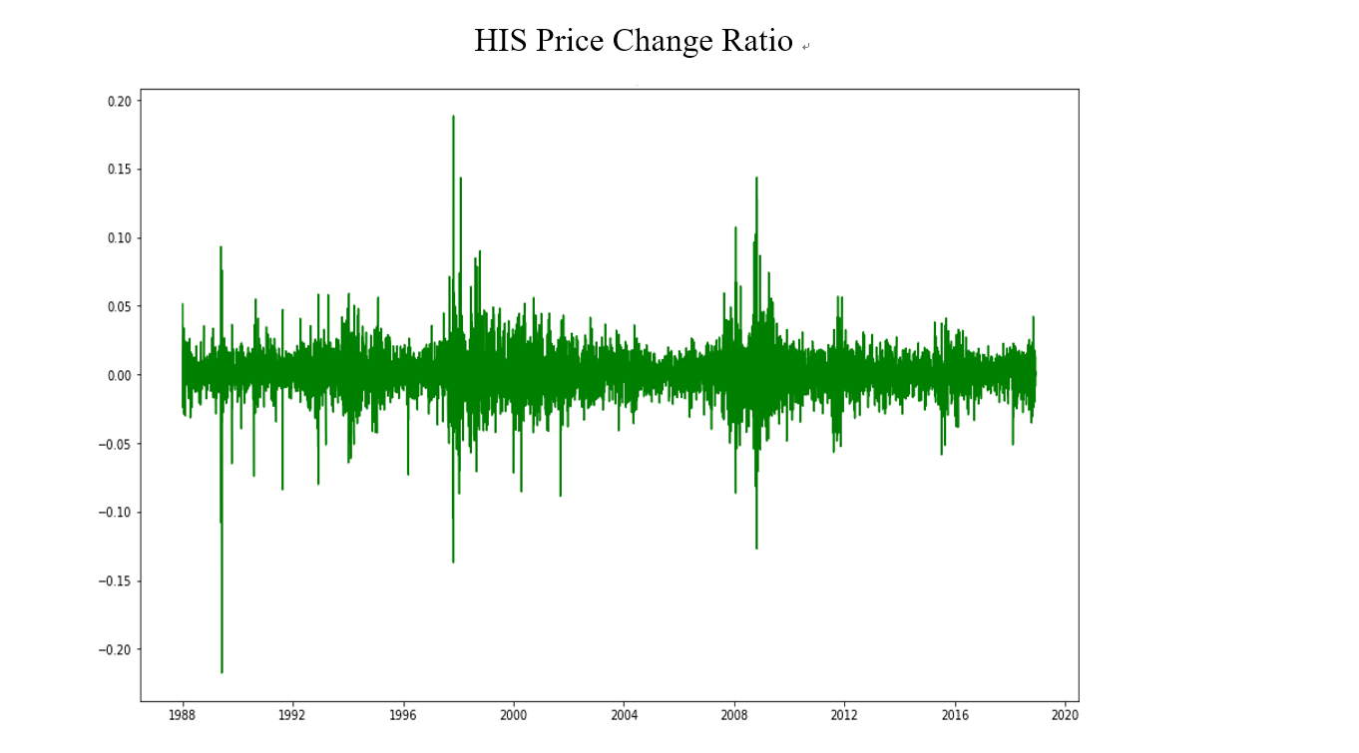

By the comparison between the trend and price change ratio of HIS Index as follows, we can find in the last three decades, 80% of the top 10 decliners and risers coincided with the time of the stock disasters. Hong Kong called this situation "Day of Big Miracle." It means after an extremely dive, the price of the stock market rose sharply in a short time. There are different explanations for this situation. Some experts attribute it to macro-control, while others attribute it to the recovery of market confidence. But whatever the reason, it represents turbulence in the stock market. As the figure shows, even if there was a big miracle day, it also usually couldn`t resolve the problem of the stock disaster at that time.

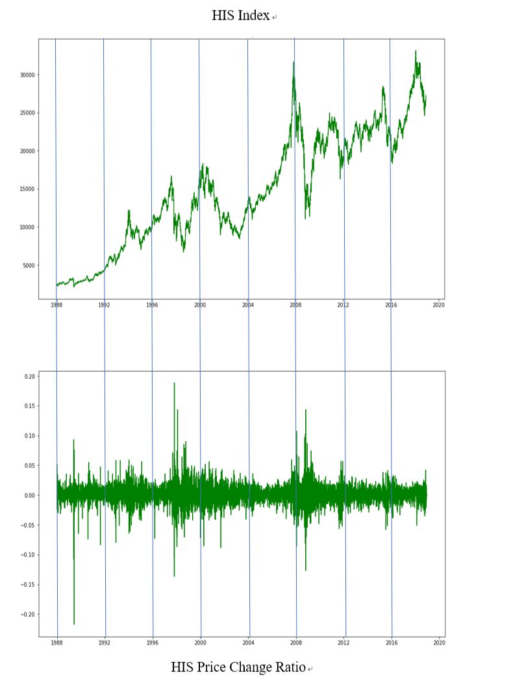

**1History of Hong Kong Stock Disaster**

The project researched the previous Hong Kong stock disasters and its reasons within 30 years, aims to predict next stock disaster. The research found that there are seven historical Hong Kong stock disasters during 1989 and 2018.

During this period, there is a Hong Kong stock disaster happened in 1989. After Tiananmen Square protests, Hong Kong people became very panic, who sold the house and desired to hold the cash in hand for preparing immigration. Following by 1994, the U.S. Federal Reserve sharp raised interest rates, due to the Linked Exchange Rate between the Hong Kong and the U.S., Hong Kong also need to follow them, which brought the effect on Hong Kong Economy. In this case, stock disaster happened.

Due to the Asian financial crisis and Dot-com bubble in 1997 and 2000, Hong Kong also were involved. Following by 2008, the well-known Global Financial crisis and Lehman Brothers’ subprime mortgage crisis also affected greatly in Hong Kong stock market, since Hong Kong is totally open market. In addition, the 2015 stock disaster is because of China stock market crash, since the handover China market also have influence on Hong Kong market.

In conclusion, there are more than four events of Hong Kong stock disasters during 1989 and 2018, which are closely relative to the U.S. market. We suppose U.S. market brought the significant influence on Hong Kong Economy.

**Trend Analysis of HS Index and S&P500 Index**

For verify the hypophysis of the relationship between the U.S. market and Hong Kong market, we draw the data of HS Index from Hong Kong and S&P500 Index from U.S. market during 1989 and 2018. As we know, these two indexes played significant role in local stock market.

**HS Index**

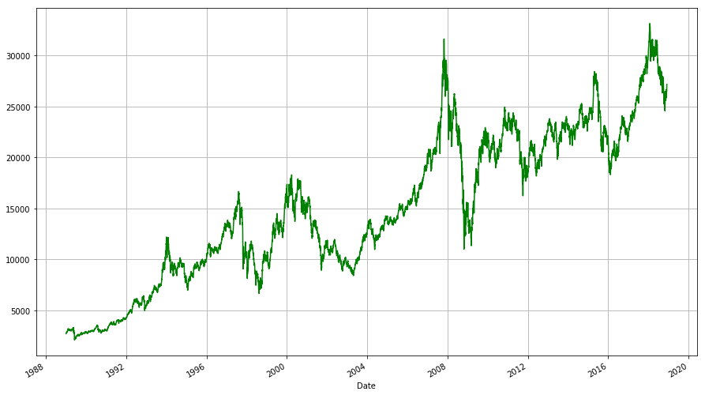

**S&P 500 Index**

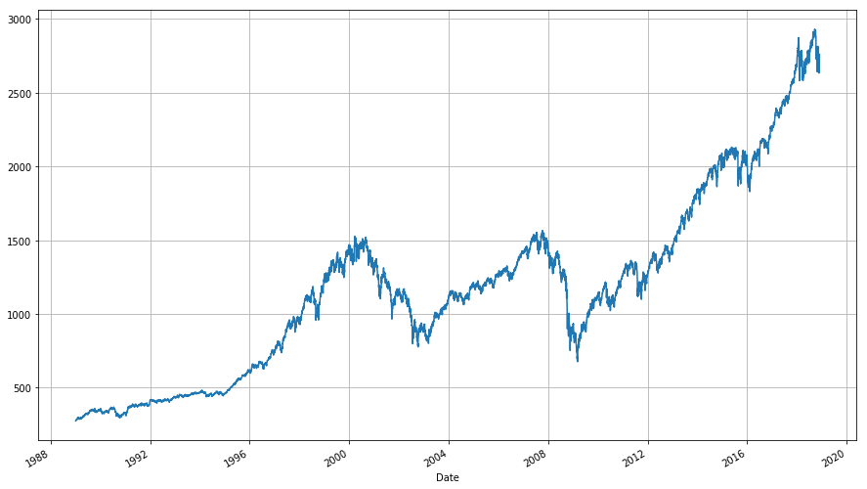

From the line charts, we could find that the basic trend is very similar between HS Index and S&P500 Index, particularly in the timing of stock disasters. By summary, the data from HS Index and S&P500 Index verifies the hypophysis that U.S. market has the significant influence on Hong Kong stock market.

**Analysis of stock disaster indicating factors**

In this part, we analyze two indicating factors of stock disaster. They are U.S unemployment rate and federal interest rate. We will put together the changing trend of these two rates with the changing trend of S&P 500 index to dig out the inner relationship between these two rates and S&P index.

When we put together the trend of HangSeng index and S&P 500 index standard up and down, divide every four year into one column. It is clear that the changing trend of HangSeng index and S&P 500 index is quite similar in each column.

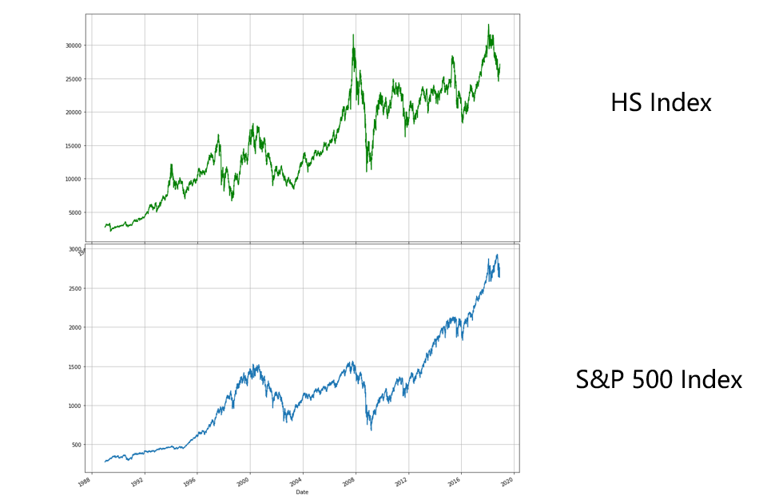

Then it comes to our first result. The similar changing trend implies that Hong Kong stocks and U.S. stocks are closely connected. Macroeconomic changes are the main cause of stock disasters. So we will analyze those changes to predict the next stock disaster.

We pick up two factors that cause macroeconomic environment change. One is U.S. unemployment rate. The other is Federal interest rate.

图片包含 文字

自动生成的说明

For unemployment rate. First, let’s concentrate on extreme points. Unemployment rate reaches the periodic lowest level around year 2000 and 2007 which are close to year of stock disasters happened in 2000 and 2008. And Its historical high points were around year 1992, 2003 and 2009. Which are follow-up years of stock disasters.

图片包含 地图, 文字

自动生成的说明

Then, by comparing the changing trend with S&P 500 index. Unemployment rate and S&P 500 index changes in opposite direction. One ascending, the other one descending, vice versa.

Therefore, we find out that the lower the U.S. interest rate, the greater the probability of a stock disaster. The time unemployment rate reaches lowest level is often the beginning of the next stock disaster.

For Fed’s interest rate, as the upper line chart shows, it peaks periodically and keep high for a while then descend. Stock disasters usually happen in this period. And for the peak rate itself, it is moving in a constantly dropping trend. Fed’s interest rate and S&P 500 index change in the same direction. We find out that the higher the Fed’s interest rate, the greater the probability of a stock disaster.

图片包含 文字, 地图

自动生成的说明

**The prediction of stock disaster through the interest rate**

After analyzing the relationship between the macroeconomic environment changes and the stock performance, we will use the Interest rate and the unemployment to predict the future.

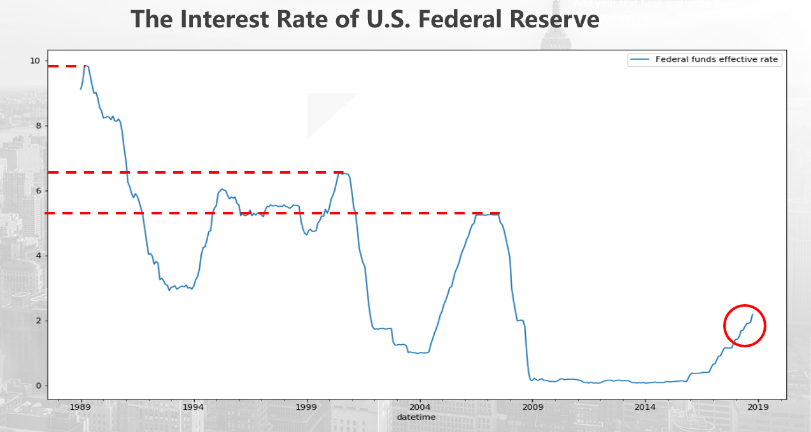

This chart shows the performance of the interest rate of U.S. Federal Reserve in 30 years. There are two outstanding trends. The first is as mentioned above, when the interest rate reached the peak, there would be a stock disaster. The second is that the peak value shows a declining trend. In 1989, the interest rate is about 10%. However, in the year 2000, the interest rate is about 6.5%，followed by a stock disaster. Just before the 2008 financial crisis, the peak value is only 5.26%. Through this falling trend, it is reasonable to estimate that when the interest rate reaches less than 4%, there will be another stock disaster.

After 2018, the U.S. Federal Reserve is increasing the Interest Rate consistently, and it shows a linear trend. When we use the linear regression model to forecast, we draw the trend line and extend, we found that in the second half of 2020, the interest rate would raise to about 4% and there may be another stock disaster.

**The prediction of stock disaster through the unemployment rate**

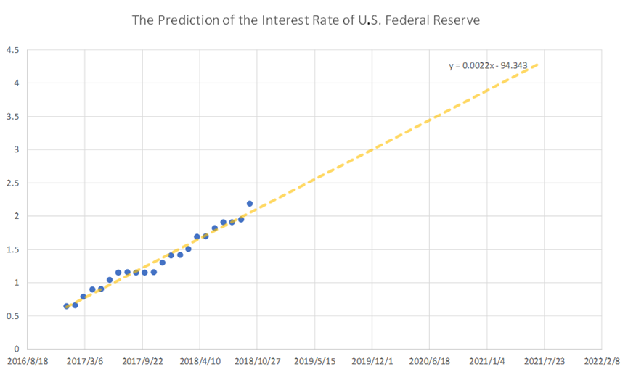

We can forecast the future stock disaster through another macro economic facter—the unemployment.

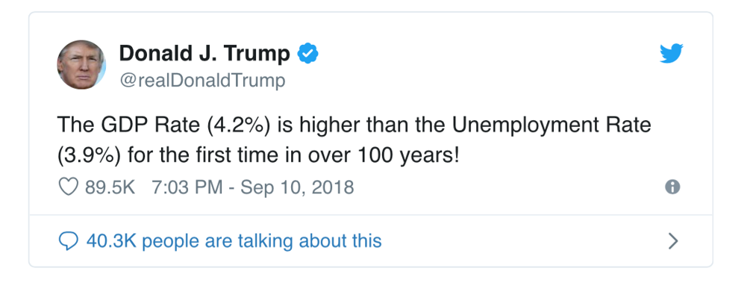

Trump twittered in Sep that The GDP Rate is higher than the Unemployment Rate for the first time in over 100 years! But is it the truth that the lower the unemployment rate, the better? Not really.

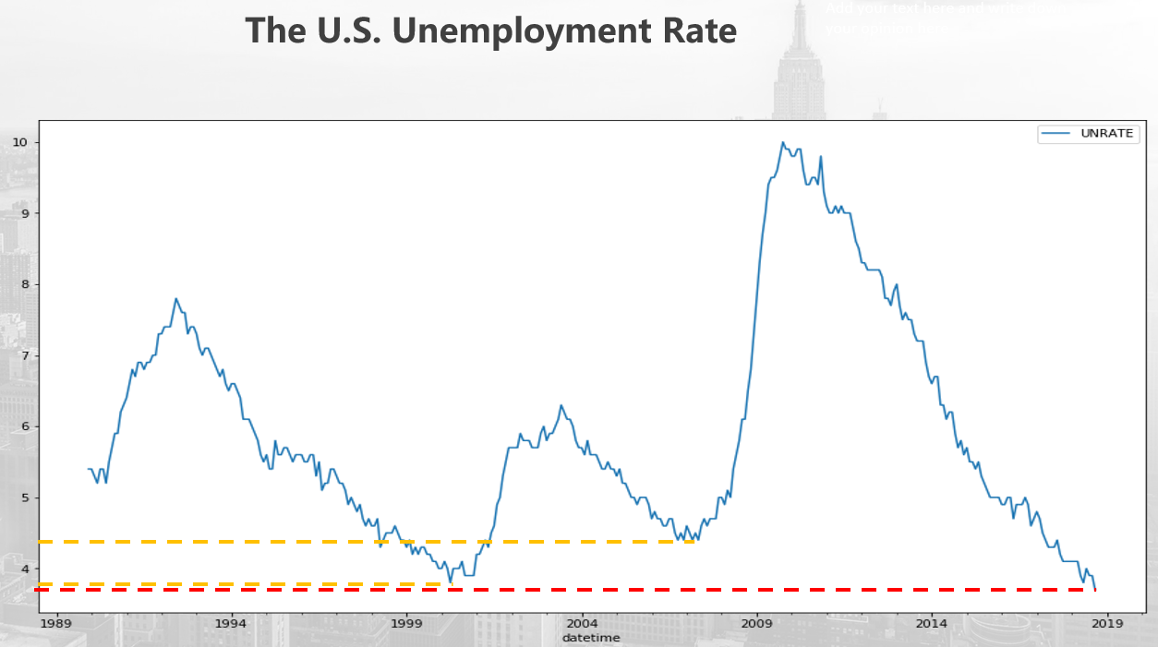

We can see from this chart, the U.S. Unemployment Rate in thirty years, which shows that each time the unemployment rate falls to the bottom, there would be a stock disaster. In 2010, before the dot-com bubble, the unemployment is about 4%. In 2008, the unemployment is also about 4%. Now, just as Trump said, the unemployment is only 3.9%, there is a great probability that the next stock disaster would happen in the near future.

**Our conclusion is: we assume that the next stock disaster would occur around 2020.**

We are not alone; our prediction is consistent with Nouriel Roubini’s forecast. He is a well-knowned economist, the economic professor of New York University. He predicts”By 2020, the conditions will be ripe for a financial crisis, followed by a global recession”. So we should be aware the potential stock disaster.